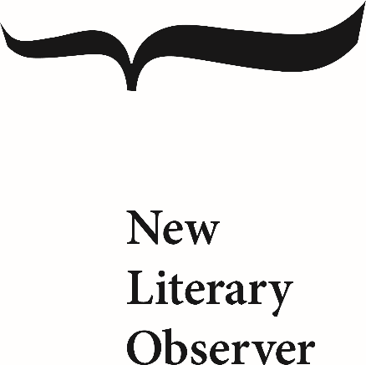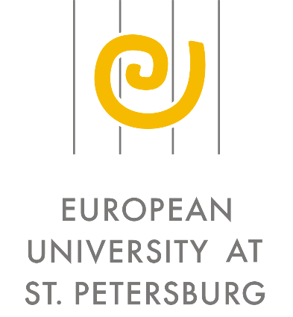

The "New Literary Observer" journal and the European University at St. Petersburg

are pleased to announce a call for papers for the 5th conference within the framework of their joint program *"The Anthropological Turn in the Humanities and Social Sciences*".

Conference Theme:

**The Anthropology of Trust**[1]

15-16 May 2020, Moscow

Although philosophers and artists have pondered over the moral and social role of trust since antiquity, a strong interest in trust as a social institution emerged only in the modern era. Adam Smith’s Theory of Moral Sentiments (1759), in trying to legitimize a new social order tied to the all-powerful ‘invisible hand of the market’, reasoned that this economic mechanism was activated by people joined to one another in ‘mutual sympathy’ (i.e., joined in trust). Alexis de Tocqueville, a major theorist of trust in the 19th century, directly linked the collapse of political regimes to citizens’ loss of trust in the ruling elite.

The late 1970s saw another spike in interest in the role of trust in society, culture, and politics. Pierre Bourdieu, in examining social capital as a resource for contesting power in various spheres of social life, discussed trust as a component of symbolic capital used in the practice of symbolic exchange and symbolic power. In keeping with the tradition of Tocqueville, Francis Fukuyama and Robert Putnam would both assign trust a leading role in the establishment and successful functioning of modern democratic societies: trust amongst ordinary citizens was argued to foster solidarity, which, in turn, prompted self-organization of civil society, civic activism, and the election of leaders endowed with public trust.

In contemporary thought, however, there are also voices that question trust as the necessary and dominant component of democratic order. Matthew Cleary and Susan Stokes argue that, as democracy matures, citizens’ personal trust in the leaders they elect is replaced by a skeptical attitude towards these leaders, and trust is placed, instead, in social institutions meant to regulate the actions of politicians. As Cleary would say, “distrust is good for democracy.”

Karen Cook, Margaret Levi, and Russell Hardin suggest that, in our complex contemporary world, trust can only be an effective mechanism for supporting social order at the inter-personal level, while higher-level social systems of cooperation are completely capable of successfully functioning without trust.

The advent of the internet has created additional problems for established norms of trust in society. On the one hand, online communications have immensely enhanced the capacity for coordinated action and horizontal organization in society. On the other hand, the internet has also generated new threats: it has eroded the criteria for reliable information, as well as destroyed traditional expert communities and reputation systems.

We invite conference participants to discuss the following questions in relation to the complex role of trust in human relations:

-How have theories of trust as the paramount ethical concept and primary social institution developed and changed over the course of history? How have practices of trust formed in different cultures and in different eras?

-How is the problem of trust and its attendant moral categories (loyalty, reliability, mutual support, and solidarity) reflected in world culture and art?

-How do epochal crises (in politics, economics, technology, gender relations, etc.) affect the level of trust in society?

-Are existing theories of trust relevant to non-democratic (totalitarian, authoritarian, etc.) societies? How can we explain the paradox of increased confidence in leaders or central figures in these kinds of political systems? Might we think about these corrupt political regimes as peculiar societies of trust?

* * *

To submit a proposal to the conference, please send a CV and paper title and description (700 words maximum) to the conference coordinator **Andrei Cherkasov** at **tovpes@gmail.com**

Please use “NLO-EUSP Conference” as the subject of the email.

**Applications are due no later than February 10, 2020**. The organizing committee will inform applicants of the selection results by March 5, 2020.

Conference participants may be awarded grants to defray the cost of travel to and accommodation in St. Petersburg.

**THE ORGANIZERS:**

NEW LITERARY OBSERVER (launched in 1992 by a cultural historian Irina Prokhorova) is the leading Russian research, intellectual and publishing center studying Russian literature, history and culture in a global context as well as promoting contemporary Russian thought in the international academic community. At present NLO comprises 3 scholarly periodicals, 2 annual conferences, a variety of educational and intellectual projects, and over 80 books per year on literary criticism, philosophy, history, cultural and interdisciplinary studies, contemporary prose and poetry.

The main task of NLO is to seek and stimulate new approaches to studying human nature and culture, to reflect on the new challenges and rapidly changing status of academic institutions with the final aim of radically modernizing the field of human studies. The NLO authors are major international experts from almost all areas of humanities: history, philosophy, cultural studies, sociology, literary criticism, and cultural and historical anthropology.

EUROPEAN UNIVERSITY AT ST.PETERSBURG. Founded in 1994 with the active support of the city of St. Petersburg, the European University began operating as an elite graduate school in the social sciences and humanities in 1996. From its inception, the mission of EUSP has been to meet the needs of Russian social development by training a new generation of teachers and scholars in the best Russian and Western traditions.  The European University is one of only a few non-state universities fully qualified by the Ministry of Education to award advanced graduate degrees. Over some 20 years, EUSP has gained an international reputation for the superb scholarship of its faculty and the training of Russia's best and brightest graduate students.

**About “The Anthropological Turn in the Humanities and Social Sciences” project**

The editors of the journal New Literary Observer and their colleagues at the European University at St. Petersburg, through their common interest in the promotion of new humanities scholarship and support for the expansion of global academic networks, have jointly established a series of annual international conferences on the topic of “Words and Things: The Anthropological Turn in the Humanities and Social Sciences.”

Against isolationist tendencies in academia and in the public sphere, these conferences are intended to be a platform for the presentation of Russian humanities scholarship to the international academic community, as well as a tool for fostering a new generation of humanities scholars in Russia and creating conditions for the development of new humanities centers across Russia’s regions.

The term “anthropological turn” here refers to the powerful intellectual trend that grew in momentum throughout the 20th century. Today, the “anthropologization” of the humanities can already be observed, with the emergence of new disciplines such as historical, philosophical, cultural, sociological, economic, medical, and other fields of anthropology. The majority of the many “disciplinary innovations” of the past 30 years – oral history, gender studies, urban studies, history of emotions, memory, trauma, history of everyday life, theories of the body, etc. – all, one way or another, fall within this larger anthropological turn.

A similar vector in the humanities can be seen across the work of many scholars, though there are differences among these scholars and their methodological approaches. This vector may be characterized most schematically as a move from the strict universals of totalizing constructions to the more flexible, detailed, and individualized studies of peoples and cultures, from the centrality of texts to the centrality of the visual and bodily, and from binary oppositions and intertextualities to cultural and philosophical anthropology.

In part, this “anthropological turn” is connected to the Soviet collapse: the dissolution of the Soviet Union and all its systems of sociocultural mythologemes set before Russian humanities scholars—and before all of Russian studies as a field—the tasks of critically rethinking the tool box and perspectives of the profession, generating new understandings of categories and aesthetic orientations, and reforming the cultural field and its institutions.

The broad framework of the “anthropological turn” is not intended to set bounds of the agenda for intellectual dialog. Rather, it aims to facilitate the expansion and development of new methodological approaches that are suited to the intellectual challenges of the coming era.

New Literary Observer and the European University at St. Petersburg hope that this new research program will attract the interest of colleagues from related fields and push Russian scholars out of isolation and into the international intellectual community.

1. Previous themes have included “The Lie as a Factor of Social Life: Practices and Texts” (2016, St. Petersburg); “Dignity as a Historical Concept and as a Key Category of Our Time” (2017, Moscow); “’A Hero of Our Time’: Leaders of Public Opinion and Their Cults in the Era of (Post)Modernity” (2018, Moscow); “The Anthropology of Fear” (2019, St. Petersburg)